1. INTRODUCTION
   1. Overview

An application Tracking System is a tool that enables your company to track and measure each step of its recruitment process.An ATS collects and stores information about your a candidates

* 1. Purpose

When a candidate applies to a job their information to uploaded to your ATS databace.Typically , this includes details like contact information qualifications and resume.

PPROBLEM DEFINITION & DESIGN THINKING

2.1 Empathy Map

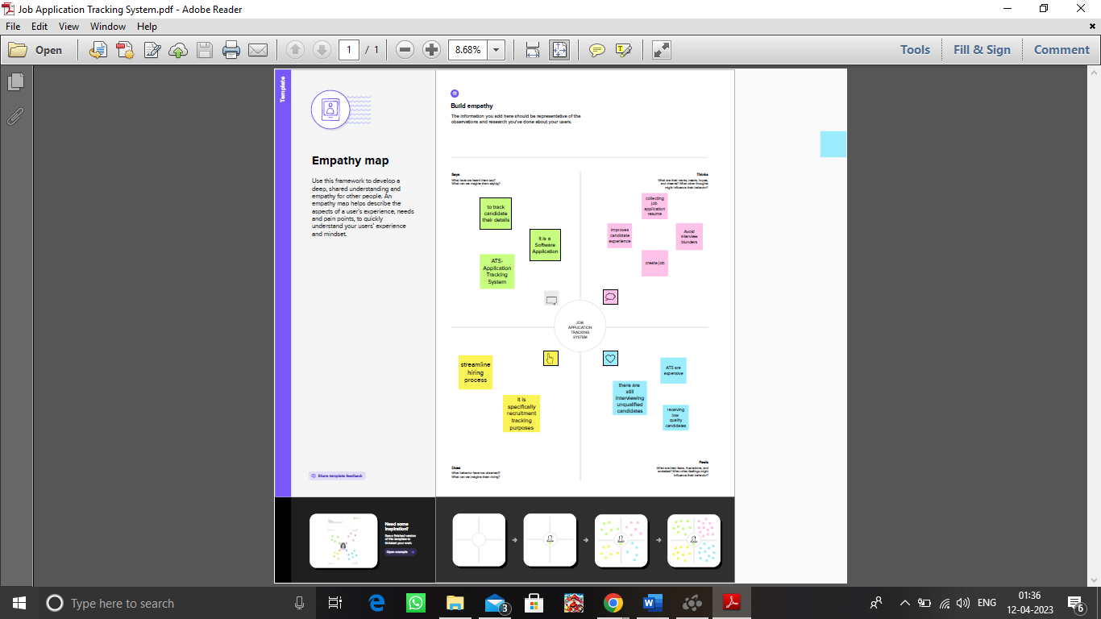

2.2 Ideation @ Brainstorming Map 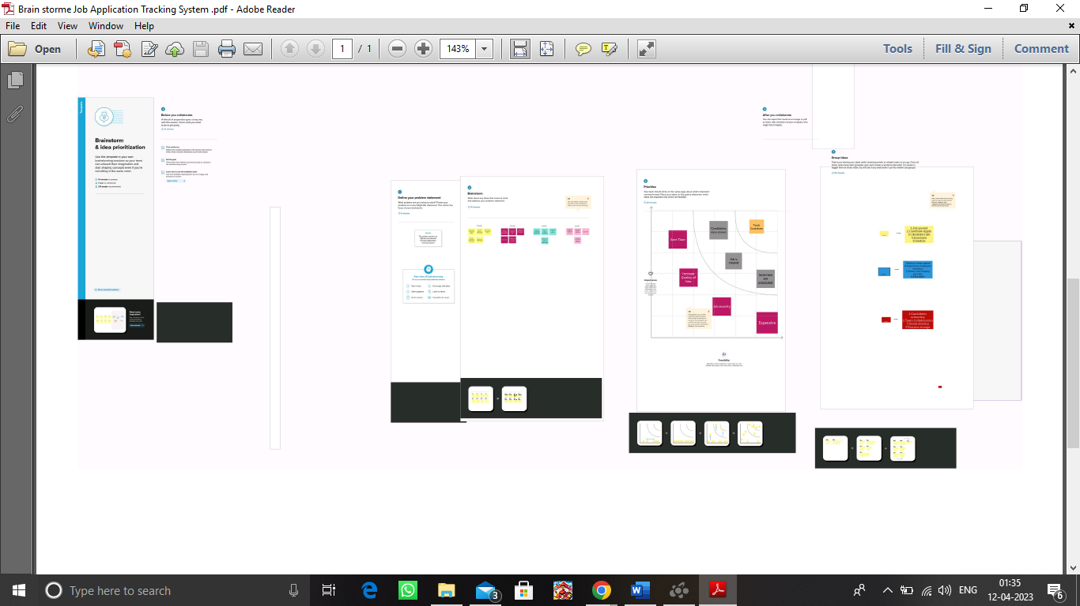

3 RESULT

3.1 Data Model :

|  |  |
| --- | --- |
| Object Name | Field in the Object |
| Object 1 | |  |  | | --- | --- | | Field label | Data type | | Recruiter | Auto Number | |
| Object2 | |  |  | | --- | --- | | Field label | Data type | | Recruiter | Master –Detail realtionship | |

Millestone3-Fields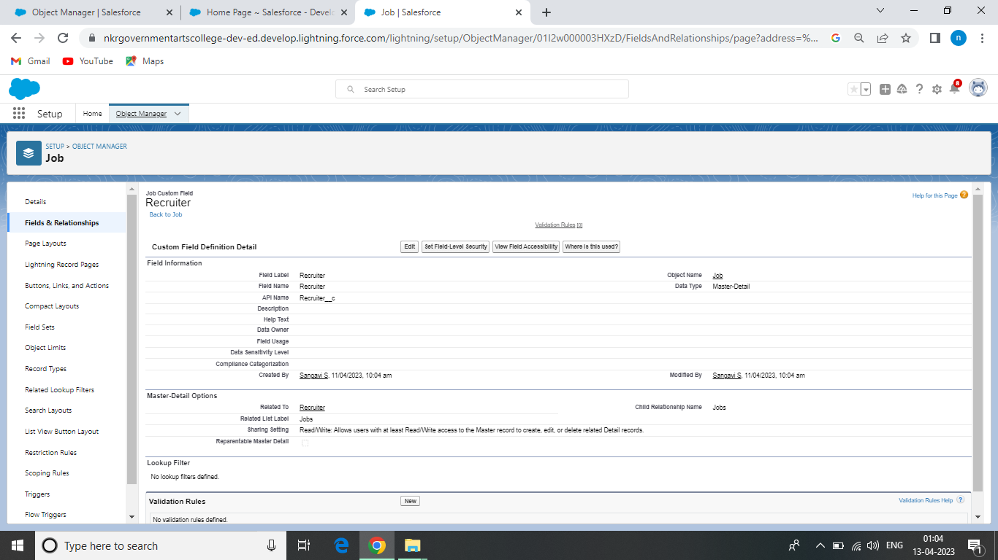

Millestone4-Tap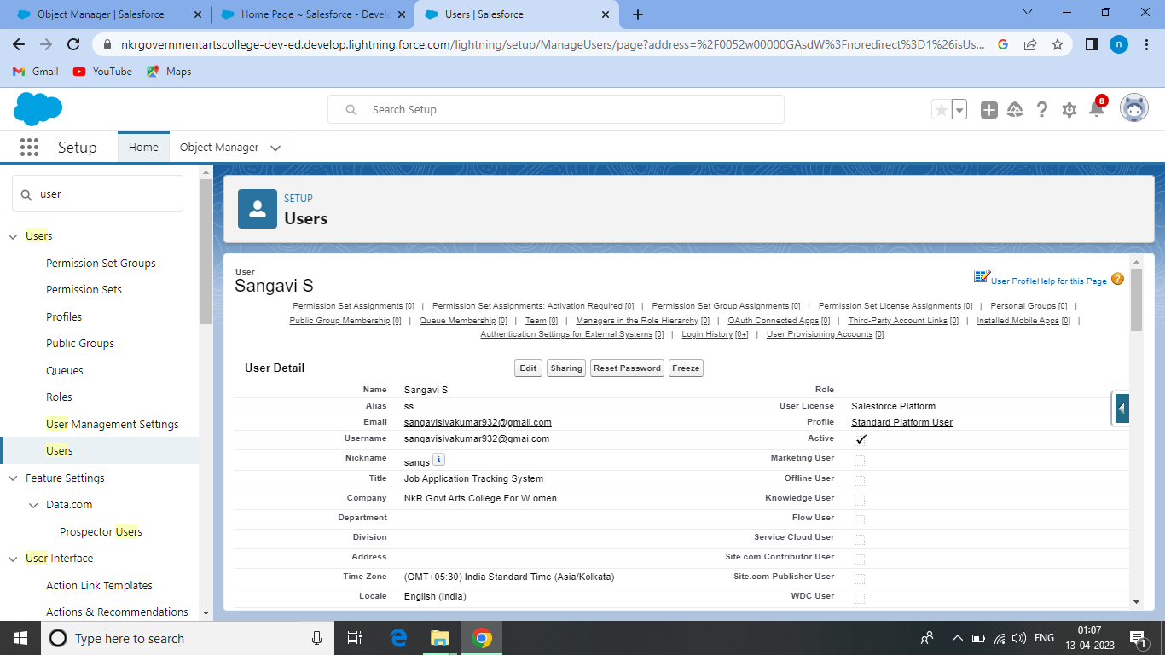

Millestone5-Profile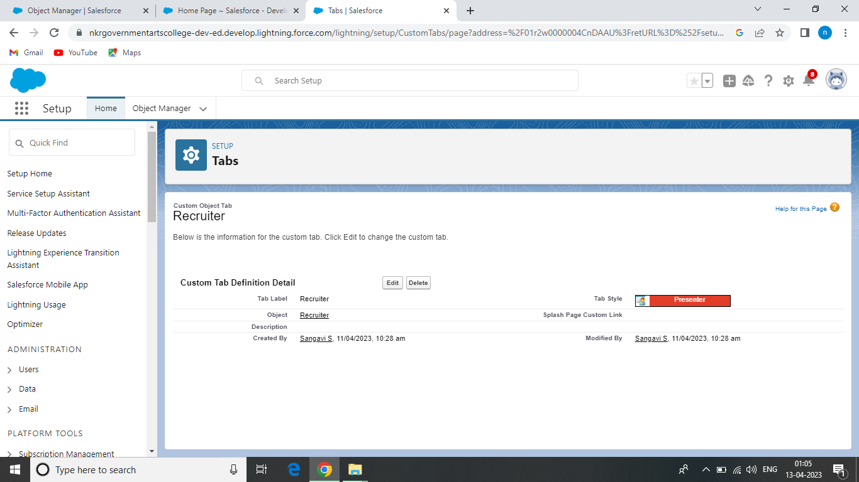

Millestone6-User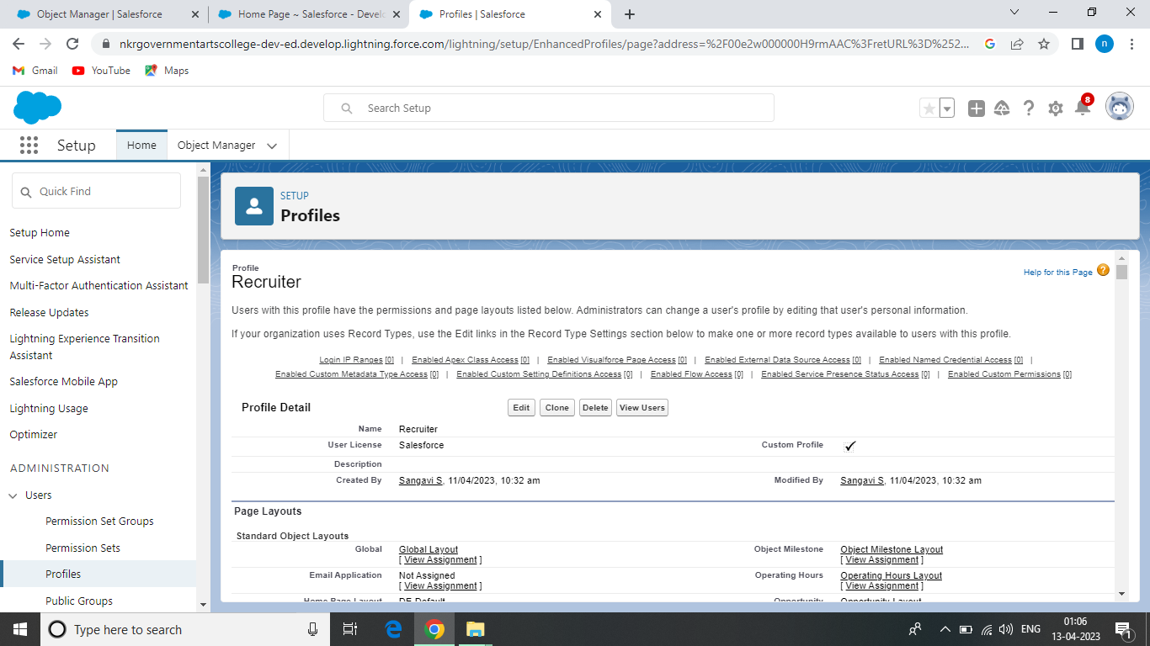

Millestone7-Sharing RulesMM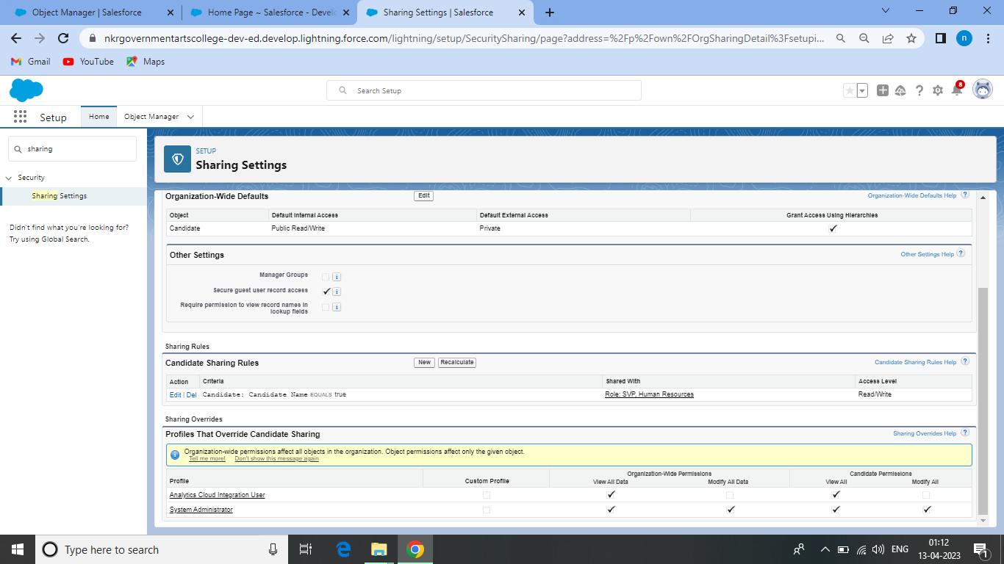

Millestone8-Reports 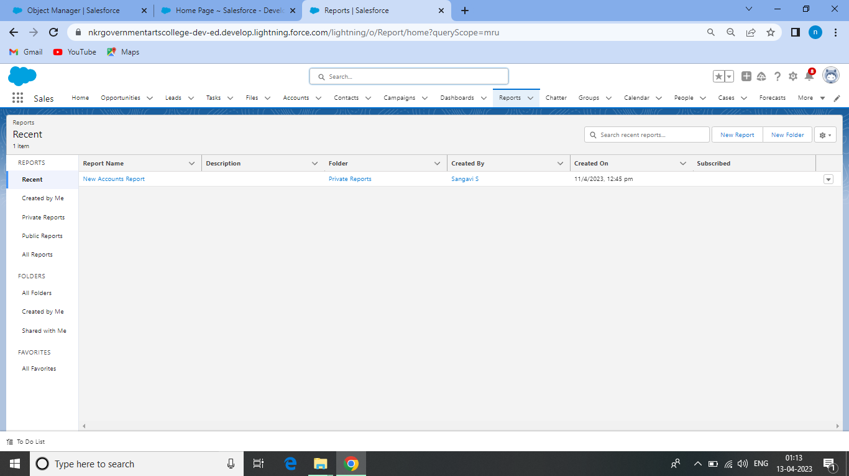

Trailhead Profile Public URL

Team Lead – <https://trailblazer.me/id/sangs44>

Team Member1- <https://trailblazer.me/id/roshp10>

Team Member2- <https://trailblazer.me/id/rasip3>

Team Member3- <https://trailblazer.me/id/ccprithika>

5 ADVANTAGE @ DISADVANTAGE

ADVANTAGES

* Using applicant tracking software seems like a great way of saving time when recruiting .
* Reduces time spent
* Allows posting of jobs
* Ensures Legal compliment

DISADVANTAGE

* There could be some drawbacks , like perhaps missing out on good applicant.

APPLICATIONS

Speed up the hiring process

Streamline hiring process

Improve the candidate experience

Able to get valuable insights

Easy customatically

CONCLUTION

Like with all technology ,there are benefits and drawbacks to using applicant tracking systems .

FUTURE SCOPP

As seen , the application of Artificial Intelligence to recruitment functions allows to automate some parts of the recruiting process ,helping recruiting connect to top talent faster.